Ethical Investment Analysis

 | Investment Name | Artesian Green & Sustainable Bond Fund
 | Investment Code
 | Date of Analysis | 24/05/2023
 | Version of Analysis | Version 2.00
 | Contact Person | David Gallagher [Managing Director & Portfolio Manager]
 | Documents Included in Analysis | Date
 | Lonsec Research Report/Sustainability
 | FSC Investment Management Questionnaire | September 2022
 | ESG/Ethical Policy | Responsible Investment Policy April 2023
 | Fund Manager Project
 | PDS | 30/08/2022 (NZ)
 | OMI | 30/08/2022 (NZ Reference Guide)
 | Ethical/Responsible/Impact Report | 2021/2022 Impact Report
 | Portfolio Allocation | Hybrid and Ethical Portfolios, core Fixed Interest Allocation
 | Changes since last analysis
1 | Fund inception | 9th December 2020
2 | Fund Manager launch date | 2004 (offices in New York, London, Singapore, Shanghai, Melbourne and Sydney)
3 | Fund Manager ownership | Was initially a division within ANZ Banking Group and was a spin-off from the bank, with an initial focus on managing credit arbitrage hedge fund strategies. Prior to separating ownership was ANZ Private Equity (30% and founding members 70%).  Now owned 100% by senior management and employees under Aroona Inc, the parent company.  Total of 51 staff across the different global locations.  Investment personnel are remunerated via a competitive base salary and where the business achieves a defined level of profitability, a discretionary bonus (20%). Also awards key personnel in the form of an equity stake in the form, but most rem is likely to be paid via business distributions at this stage. Zenith note a deferred equity share agreement for PM’s based on increasing the FUM over the next three years.
4 | Fund Manager profitability | Profitable – focus of KPI’s for remuneration
5 | Asset Classes | Absolute Return Fixed Income Fund Manager
6 | Total FUM of business | AUD $1 billion
7 | FUM | $123m AU of which $55m Future Super (seed investor)
8 | ICR & Performance Fees | 0.30% + 0.20% = 0.50%
9 | Buy/Sell Spread | 0.10% each way
10 | Frequency of pooled fund unit price calculations
11 | Directors | Matthew Clunies-Ross, Jeremy Colless, John McCartney
12 | Investment Team | Large global, experienced team of fixed income professionals trading and analysing credit markets 24 hours a day.  CIO and founder – Matthew Clunies-Ross, plus 8 others across the world. Clunies-Ross works closely with Portfolio Manager David Gallagher. Clunies-Ross has industry relationships which are pertinent to the assessment of primary issuance deals and relative value opportunities, while Gallagher’s experience in managing fixed interest mandates aids in the setting of investment strategy and risk allocation. Skillsets are complementary.  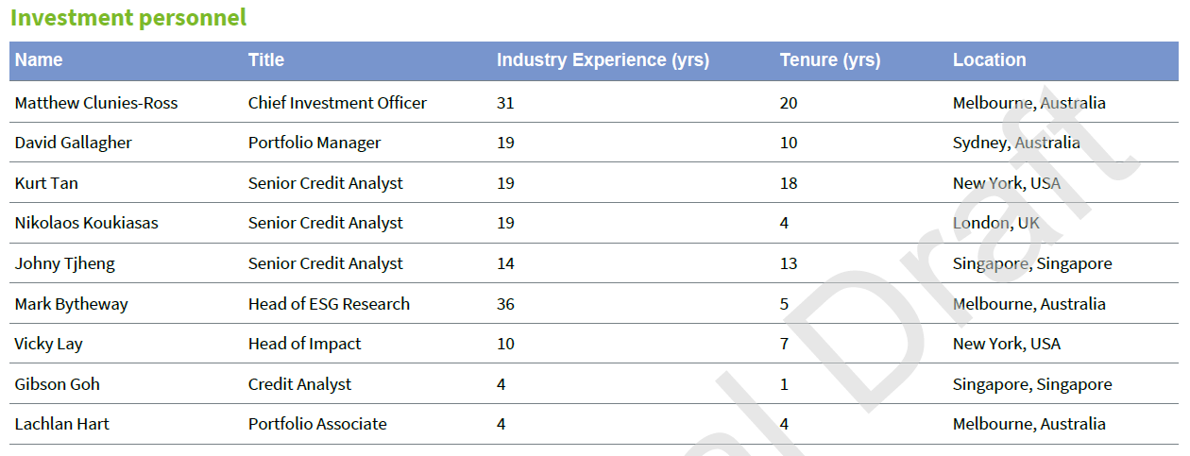  Team for this investment 9 people.  There is a specific Investment Committee that meets two monthly to consider the investment strategy and produces outputs for Clunies-Ross and Gallagher, which composes four members – Co-PMs and includes Mei Lee (head of operations & investor services) and Dan East (CIO of Future Super and seed investor of the Fund), but has a current right to veto – which in Zeniths opinion may not be appropriate). The Clean Energy Finance Corporation also has an observer seat (non-voting).  There is very little crossover on bonds held within other funds.
13 | Investment Team Remuneration | Salary + bonus which is tied to performance and business profitability
14 | Succession Planning and Key Person approach | Matt can be replaced by David and vice-versa. David is currently hiring for a junior analysts/PM who will be his understudy.
15 | Business Continuity Plan for Key Person Risk in this fund | As above, Matt and David are PM’s so key person risk is limited.
16 | Training for new team members senior/junior | New team members are given an internal buddy who integrates them into the firm. New hires are encouraged to travel to the other offices around the country and learn about the business. Employees are also offered the chance to do additional courses like the CFA ESG accreditation.
17 | Investment Approach/strategy | Artesian are a global, absolute return fixed income fund manager focused on relative value opportunities in credit markets who manage niche strategies, with the overriding goal of producing consistent alpha and best in class risk adjusted returns for our investment. Committed to integrating ESG into our investment process with a focus on responsible investment.  The Fund will invest in global green and sustainable corporate bonds and cash. These corporate bonds will be issued by Australian and international companies  Diversified portfolio of liquid, predominantly investment grade fixed and floating rate green and sustainable corporate bonds.  Diversified exposure to an asset class that is very difficult to access- green and sustainable bonds. Daily Liquidity and quarterly distributions.  AUD focused fund with the ability to buy EUR & USD securities also. Actively Managed  Approach Macroeconomic landscape which sets the broad risk stance of the portfolio, assess key market indicators to draw a conclusions on current environment and whether it is conducive to risk taking or a more cautious stance. Credit spread and interest rate duration targets are set.  Specific ‘UOP” Use of Proceeds analysis for the green and sustainable bond ethos.  Only allowed to invest in (rated BBB- or higher)  Green Bonds  Sustainable Bonds  Sustainability Linked Bonds  Social Bonds Issuers  Benchmark = Bloomberg Ausbond composite 0-5 year index  Final portfolio expected to be relatively concentrated comprising 30-40 positions, with at least 80% invested in investment grade credits.  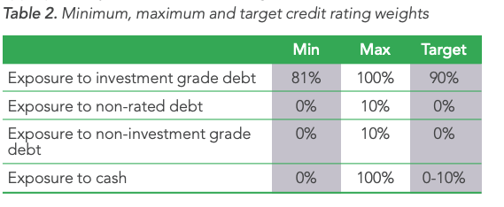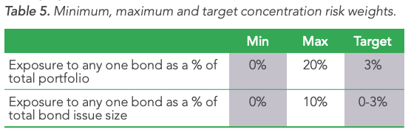  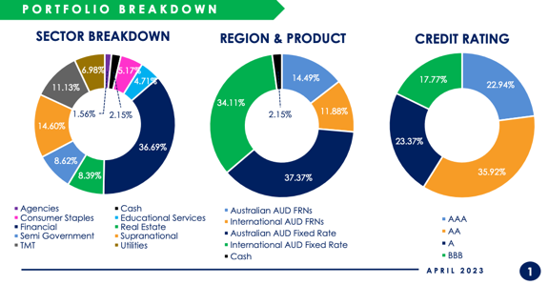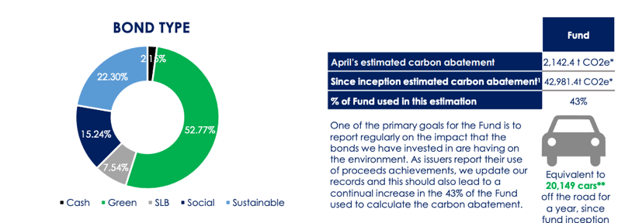
18 | Investment Process | 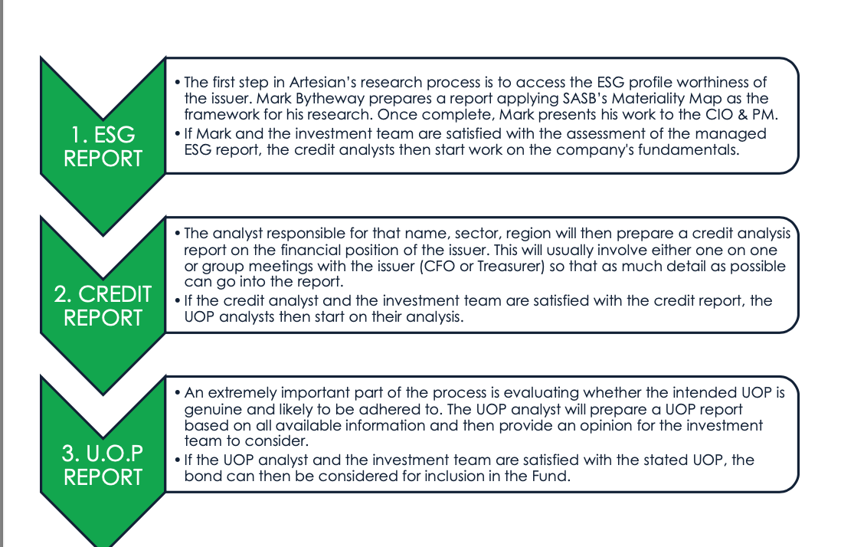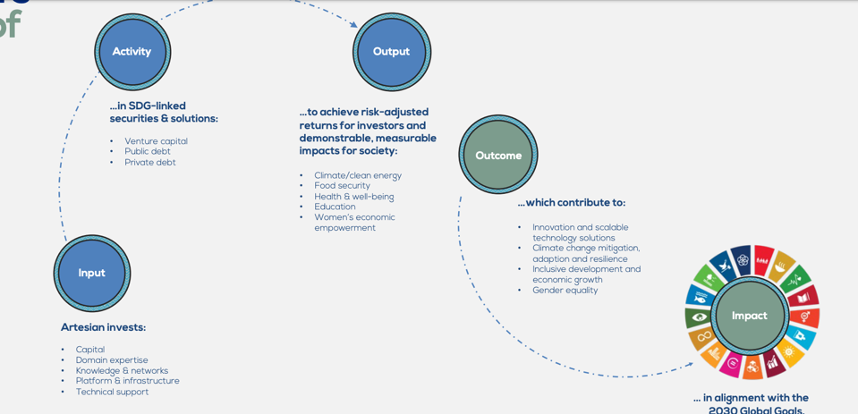  Our proprietary credit analysis framework integrates bottom-up ESG research in order to enable our portfolio managers to better assess investment opportunities.  We then seek to determine and assess for material impacts, risks and opportunities and the manner in which these managed. This analysis and assessment is incorporated into our investment decision-making process via reports, presentations and engagement with bond issuers
19 | Ethical Process | ESG integration occurs across Artesian’s investment platform based on the product’s asset class & the investment teams’ specific processes & strategies.  Will only invest in bonds that have women on the board  Responsible investing is widely understood as the integration of environmental, social and governance (ESG) factors into investment processes and decision-making. ESG factors cover a wide spectrum of issues that traditionally are not part of financial analysis, yet may have financial relevance:  Environmental  - Climate change & carbon emissions  - Energy efficiency  - Pollution  - Natural resources use  - Waste management  - Clean energy & tech  - Biodiversity  Societal  - Labour relations  - Diversity agenda  - Employee safety  - Product safety  - Human rights  - Child labor  - Working conditions  Governance  - Board diversity  - Auditor independence  - Corruption and bribery  - Anti-money laundering  - Business ethics  - Cartels and price fixing  - Compensation policies  Positive Screens:  - ESG positive filter – desktop research, Sustainalytics, Bloomberg, Moody’s, Equileap  - Impact measurement – we analyse the annual impact report published by the bond issuers to calculate the pro-rata impact for the fund.  - Positive gender bias – desktop research, Sustainalytics, Bloomberg, Moody’s, Equileap  - Climate focus – net zero goal, impact goals  - Preference for green, social, and sustainable securities – desktop research  Artesian’s approach to corporate disclosures looks at 3 levels:  - Issuer – annually reported data from public companies gives us guidance on all the activities a company is engaged in. Using industry templates, we can seek similar disclosures from private companies in our portfolios on a more regular (say quarterly) basis. Impact metrics and narrative may be opaque and require scrutiny.  - Sustainability Performance Targets – monitor KPIs that companies set around sustainability goals. This can come in the form of project factsheets or be combined into issuer or security level disclosures. Data provides clarity for engagement with the company.  - Security – gives a direct line of sight to what impact our investor’s capital is making. We require annual use of proceeds reports from bond issuers, so we can analyse and report back to our investors on the impact their capital is making. Impact metrics and methodologies have normally also been scrutinised by consultants which adds another layer of oversight.  Our corporate bond exposures are the result of negative screening combined with a positive ESG overlay and a preference for green, sustainable and social securities. This preference for labelled bonds means we derive most of the impact data at the security level.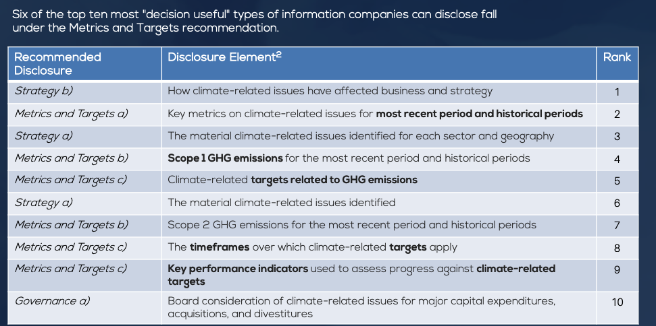
20 | Risk Management Strategies (including liquidity management)
21 | Actual Exposures/Mindful Money analysis | Nil
22 | RIAA Certified/Rated (Responsible Returns.com.au) | No
23 | RIAA Member | No
24 | RIAA Responsible Leader | No
25 | B-Corp Status | Yes, since April 2022
26 | PRI Signatory | Yes, since February 2019
27 | Collaborative Engagement memberships & Signatories to  Green is Ethical orientation | UNPRI & Bcorp.
28 | Initiatives supporting | WE Fund - Impact Partnership to Support Investments in Gender Equality and Women’s Economic Empowerment (launched May 15 2020 with UN Capital Development Fund).  SheSyndicate.org - Non profit  1. The Paris Agreement  2. The Taskforce on Climate Related Financial Disclosure (TCFD)  3. The SDG Goals and targets  4. Impact Management Project (IMP Framework)  5. UN Principles of Responsible Investment
29 | Consistent internal question list for companies? | Yes, all research developed in a standard template.
30 | Active Share/Turnover information | Turnover 20-30% a month, very active manager  Active Share N/A
31 | Level of ESG integration (to Board level?) | INTERNAL  Sustainability Steering (SS) Committee. Weekly meetings for ESG thought leadership and cross functional co-ordination across the firm, aligning on ESG issues and controversies, risks, threats and opportunities.  ESG Committee – Quarterly open forum for all employees to discuss ESG issues and approve policy changes.  Reference to the Paris Agreement and TCFD reporting mechanisms help track the outcomes of investments.
32 | Philosophy/Policies
 | ESG Awareness | Yes
 | ESG Integration (RIAA) | Yes
 | Negative Screening (RIAA) | No
 | Corporate Engagement & Shareholder Action (RIAA) | No
 | Positive Screening (RIAA) | Yes
 | Sustainability Themed (RIAA) | Yes
 | Impact Investing (RIAA) | No
33 | Focus | The Artesian Green & Sustainable Bond Fund will invest in a diversified portfolio of liquid, investment grade fixed and floating rate green, sustainable and social corporate bonds. The Fund invests in Australasian and global issuers.  ​  Additional Fund Benefits:  ​  - Using capital for a better future, not just a return  - Same return as a regular or “brown” bond fund  - Virtuous cycle of sustainable capital & job creation  - Investment income from a positive, sustainable source  - An additional source of risk management, excluding sectors more exposed to litigation and environmental issues  We invest in bonds that have a measurable and verifiable carbon reduction impact.  - Fuelling the Renewable Energy Transition  - Agriculture Revolution & Global Food Security  - Tackling Global Health  - Business Purpose and Accountability
34 | Research inputs | SASB’s Materiality Mapping (Sustainable Accounting Standards Board).  Bloomberg  Sustainalytics  Equileap [The most comprehensive global database on gender equality, with metrics including female representation at all levels of a company, the gender pay gap, parental leave and anti-sexual harassment policies.]  Moody’s
35 | Proxy Voting services | No voting, Bond Fund
36 | Voting policy | No voting, Bond Fund
37 | Screening For | Use of Proceeds questionnaire
38 | Fully Excludes | Production of fossil fuels  Tobacco  Gaming  Alcohol  Cluster Munitions  Landmines  Pornography  Casinos
39 | Materiality minimums
40 | Responsible Investment Policy? | Yes
41 | Active Engagement purpose and policy | Engage with the issuers to drill down on the Use of Proceeds claims to ensure that they are genuine.  Follow UN PRI guidelines as follows: 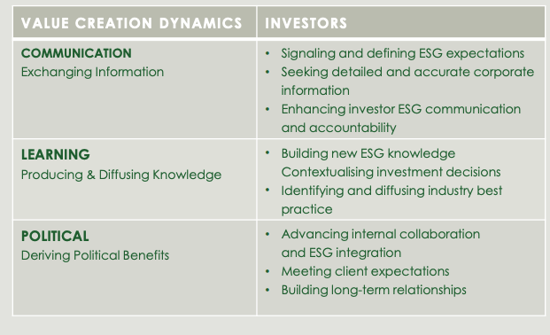
42 | How is active engagement managed? | When we meet with an issuer on engagement, we send through questions prior and then post the meeting send the issuer our file note and any outstanding follow up.
43 | Tracking engagement | We have a file note written for each engagement which is filed under the issuers name in the quarter of the year the meeting was had. As we discussed we may look into further enhancing this, Carey mentioned sending us some methodology used by another manager (Pengana WHEB – sent information)
44 | Engagement success stories? | We have been a part of some success stories – updated in annual reports and presentations. A few examples shown in our meeting in May 2023.
45 | Walking the Talk | 5 P’s that drive our actions are:  Purpose – financial and impact outcomes of our investment decisions. Both Financial and impact outcomes need to be measurable and reported transparently.  People – Diversity, social equality, governance and economic empowerment.  Planet – Innovation and technology have a deflationary effect on the cost of infrastructure required to address critical global issues like climate change – and can also ensure a rapid and scalable deliver of solutions, given the existing time constraints to mitigate climate crisis.  Product  Profit  In addition to the ethical investment overlays (positive filters and negative screening) applied across Artesian funds, we believe it is important to measure and continuously improve our operations and business model impact on workers, community, environment, and customers.  Responsible Business Planning Task Force (for B-Corp certification, but has now been renamed Impact Reporting Taskforce. John, Mei, Kurt and Vicky. Data and content collection for impact reports across the entire business. Meets weekly right before the Sustainability Steering Committee.  Weekly ESG Thought Leadership Committee and bimonthly Sustainability Steering Committee (SSC), in order to ensure alignment with our ethical values as a firm and continuous impact improvement. SSC meets weekly to discuss all things ESG, such as changes in regulation, any specific company issues, Artesian’s own progress with various rating agencies, impact reporting and so on. DEI committee meets regularly to discuss DEI staff training, policies, DEI impact reporting and so on.  Public disclosure of gender pay gap  6 weeks added to paid maternity leave policy.  New initiatives put in place:  - Employee Assistance Plan (for mental health and wellbeing) EAP (Employee Assistance Plan for mental health and wellbeing) have been implemented for all Artesian staff. All Artesian employees are eligible for reimbursement of out-of-pocket expenses for 6 mental health sessions with a mental health practitioner of your choice.  - Calculation of our own operational carbon footprint with a goal of targeting Net Zero Emissions by 2030 as a business  - Screening/evaluation of “Significant Suppliers” for environmental impact (long term this would evolve into formal adoption of a Supplier Code of Conduct) We are undertaking a staggered approach to review supplier contracts for assessing risk surrounding environmental impact and modern slavery, with an aim to produce Supplier Code of Conduct by year end.  - Measurement and reporting of aggregate carbon footprint / SDG alignment of our portfolios; Yes, this is part of Artesian’s HR policies since 2021/2022. We have also reviewed and updated our parental leave policy that have been implemented firm-wide from June 2022. The suite of HR policies and Responsible Investing policy are available to staff via our HR platform (Employment Hero).  - Implementation/establishment of responsible business practices and policies, including Artesian's HR Policies to Attract & Retain Diverse Talent.
46 | Carbon Intensity Measures | Carbon abatement for the fund reported monthly
47 | Climate emissions targets | Committed to Net Zero by 2030  Measuring Carbon Footprint – (Greencollar.com.au)
48 | Carbon Credit/Offsets practice | Scope 1 and Scope 2 net zero emissions year ending June 2022
49 | SDG’s alignments | Map yes.  We map as per the offering documents of the bond, almost always the bond documents will align with SDGs, where they don’t we allocate based on the projects the bonds will be financing. When the bond issuer releases their annual impact report we then check the impact achieved over the previous 12 months to check it aligns with the SDGs originally targeted.
50 | Impact/Sustainability/Other indepth annual report? | Yes
51 | Comparative historic returns | 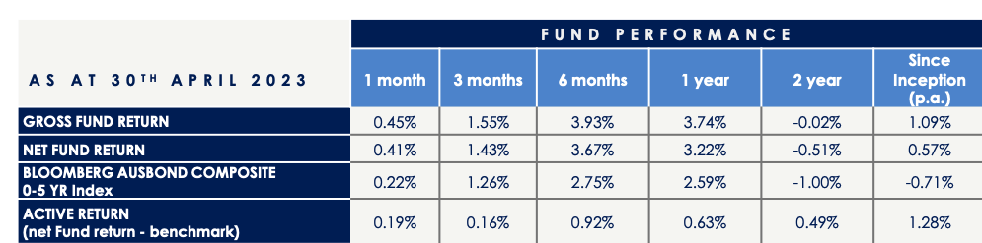
52 | Morningstar (Sustainalytics)
 | Sustainability Rating
 | Historical Sustainability Score Percent Rank
 | ESG Rating
 | Carbon Risk Score
 | Fossil Fuel Involvement
53 | Lonsec Research | Don’t pay them to rate them, prefer Zenith. Zenith Recommended.
54 | Compliance Functions| Manual | Officer
55 | Regulatory Compliance
56 | Employee Compliance
57 | Financial Crime Prevention
58 | Does the organisation have the resources (Size/profitability) available to fulfil regulatory and risk management requirements.
59 | Is/or has the organisation entered into a growth phase that has outstripped their staff capacity.
60 | What is the staff turnover – Does this create a good or negative impact?
61 | Does the Board have independent directors? Diversity? Is it overboarded?
62 | Have the systems, processes and capability kept pace with the growth of the business?
63 | Is the business continually evolving and changing and keeping up with market requirements?
64 | Have you had any unit pricing or valuation errors in the last 24 months? If yes, how did they occur, how were they identified and how were they rectified?
65 | What do you outsource and how often is that relationship reviewed? Who undertakes that review?
66 | Who makes the final decisions on security selection/asset allocation (for Multi Sector Fund)? What happens if they aren’t available?
67 | Duplication of exposure with other investments Stock Intersections | Not applicable, this is our only Global/Australian Fixed Interest Fund.
 | RIAA Spectrum Positioning | Sustainability Themed
 | General Notes | Currently offered as an AUD FIF – NZ Fund being launched in May 2023 with Devon as the NZ Distributor.  Artesian are also a Venture Capital Business – a lot of the offerings are around this, so VC plus Ethical.
 | Comments | Green bonds are still a rare and highly sought after asset class and have different methodologies and impact.  Future Super is seed investor with $55m are investors into the funds.
 | Summary paragraph for explaining to clients | Artesian are an Australian fund manager specializing in fixed interest and venture capital investment. We are using their ethical global fixed interest fund, which focuses on fixed interest issues that are regularly linked to sustainability goals. Artesian are deeply analytical, do their own research, with some research inputs and will walk away from an investment if it doesn’t walk the talk with the proposed UOP (Use of Proceeds) statements.  This fund is a New Zealand PIE.
 | Additional documentation to share with clients
 | Reviewed by | Carey Church FSP 86101

